Brief for creating a sample Unity project, for in-person training on 23rd September

- Deadline of 1st draft: Sunday the 13th September
- Deadline of adjusted final project: Friday the 18th September
- VR headset system: Meta Quest 3, with two controllers

Overall Experimental paradigm
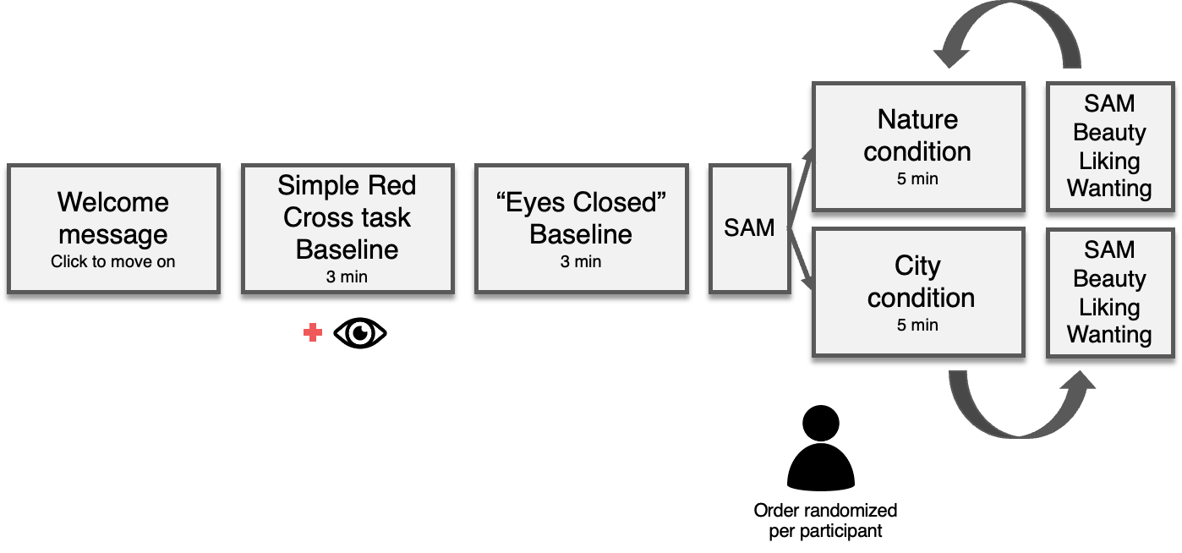
1. Welcome Message:
The welcome message should include an introductory text to the experiment (e.g., see above), and an option of moving on to the next scene by using the controller.
Welcome!
This is a sample Unity project for the in-person training/tech.
We will begin with two resting state recordings,
where for the first 3 minutes you will be asked to look at a cross,
and for the second 3 minutes you will be asked to close your eyes.
Please let the researcher know once you're ready to begin.
Click here to move on
e.g., you can have a separate box where the participants can click using their joystick, on which will bring them to the next scene/block.

2-a. Resting State Eyes Open (3 minutes)
This block could begin with a simple instruction and a countdown from 3, 2, to 1, then followed by a quick flash of the word “begin” simultaneously with a beep sound.
*FYI: For LSL purposes, we’d need the “begin” + beep sound to be an event that we can mark (sent as a trigger).
(Could begin with 3, 2, 1 – counts)
Please sit still, relax, and fixate your gaze on the red cross.

3
2
1
Begin (with beep)



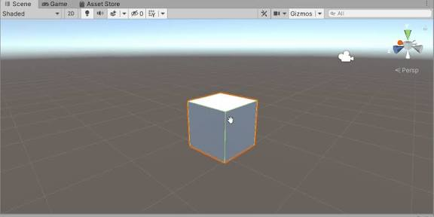
The cross could be against a default Unity grey background (e.g., image above), where you can add a red cross.
*Optional: You could make the cross black and make the cross randomly turn red briefly (1 second) for certain moments. In this case, add in the instruction above, “Count the number of times the cross turns red.”

2-b. Resting State Eyes Closed (3 minutes)
This block could begin with a simple instruction, and a countdown from 3, 2, to 1, followed by a beep, then 3-minutes, perhaps another gentle beep after the 3 minutes to let participants know 3 minutes have passed.
Again, this could still be in the default Unity grey background, but adding in a simple black-line illustration of closed eyes.
Also, again for LSL purposes, we’d need the “begin” + beep sound to be an event that we can mark (sent as a trigger).
Please sit still, relax, and close your eyes for 3 minutes.

3
2
1
Begin (with beep)
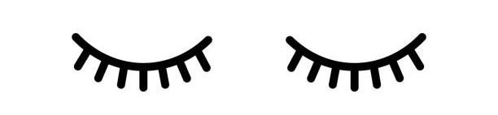

After the eyes closed block has run since the “begin” + 3 minutes, it can automatically move onto the next SAM block.

3. SAM (Self-Assessment Manikin)
Within this block, you can create two different scenes – one for measuring Valence (positive-negative emotion) and another measuring Arousal (calm-excited).
Participants should be able to choose on a scale from 1-6, by moving their joystick and clicking on the number. You can be a bit creative with how to design this (e.g., making them 3D, overlapping the numbers with the manikins, etc).
However, please strictly adhere to the original manikins for their shape and facial expression, since they are scientifically validated.
Valence_Baseline
How unhappy or happy are you feeling now?

Unhappy Happy
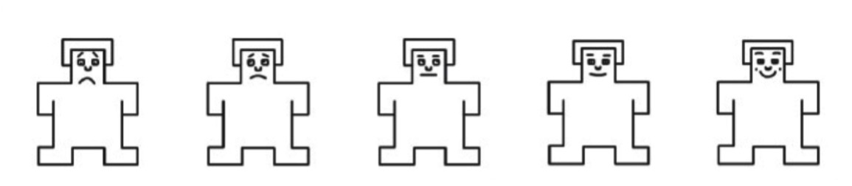
1 2 3 4 5 6

Arousal_Baseline
How calm or stimulated are you feeling now?

Calm Aroused
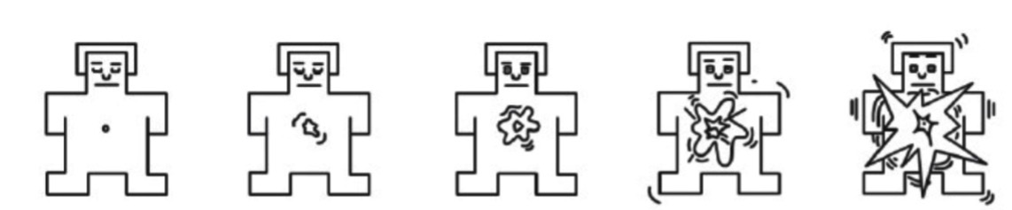

1 2 3 4 5 6

Clicking the Valence response should automatically bring participants to the Arousal block. Clicking the Arousal response should bring them to the second introductory text (e.g., see below) and an additional box which they can click, which will take them to the Conditions block.
Thank you for completing the resting state recording and the survey.
Now we begin the real experiment.
You will be shown two different scenarios,
and after each scenario, you will be completing a simple survey before moving onto the next.
Please tell the researcher when you're ready to begin.
Click here to begin

4. Two Experimental Conditions, followed by SAM & Aesthetic Judgements
Here, you can create two very different sample Unity scenes (Condition A & B), each followed by a similar SAM survey (+ liking, beauty judgements). If you can, you must try to present the Conditions and follow-up survey in a randomised order. If this is too complex, we can make two identical projects, where one project has an order of Condition A – survey A - Condition B – survey B, and the second project has an order of Condition B – survey B – Condition A – survey A.
For creating the scenery for the conditions, you do not need to spend any extra time making it better quality. What we need is a clear distinction between the two.
4-1. Condition A. Nature (5 minutes)
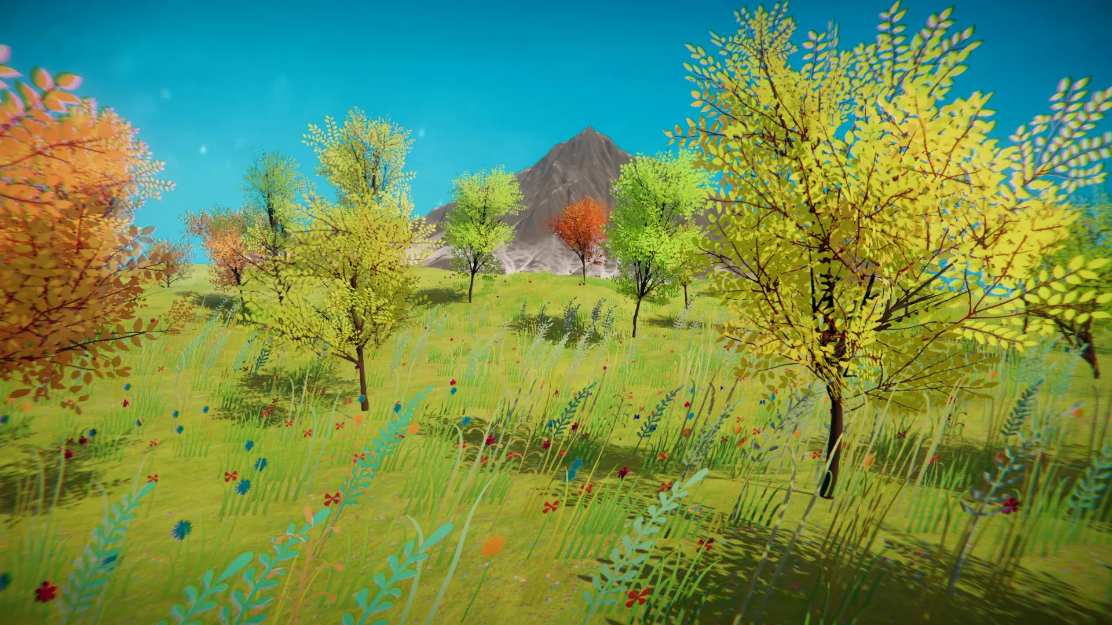https://assetstore.unity.com/packages/3d/environments/free-stylized-nature-environment-96371?srsltid=AfmBOoq7yYzTGqPACdWtkkYRyLzVUhADiLbLLZeZofFWkapQT2ERLfbL
This scene could be more nature-based, have more curvature, greenery / blue water spaces. I can help you with providing or searching some sound/recording from nature, For example, it can be something like the below – or it could be a lot simpler as well.
(Hennie to update on the possibility of a 360 video of nature).

4-2. Condition B. Urban
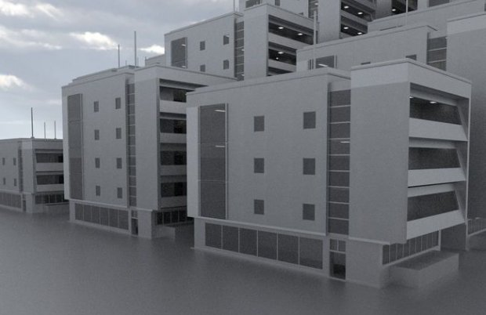
This condition could be more urban-based or artificial-based, with less colour, straight lines and cubes. Again, I can help you with finding a soundscape.
E.g., see some free city assessts for Unity:
https://free3d.com/3d-model/array-house-example-3033.html
and
https://assetstore.unity.com/popular-assets--cities?srsltid=AfmBOoqfs-uSvE2F4BGTxpWYWxn6f54QIZwc3R01QVS8jOKUiGkTbcV6#free-cities-fZwT
(Hennie to update on the possibility of a 360 video of nature).

*For both Conditions, you can follow the guidelines below:
Each of the condition should begin with the guideline, the text can be overlapped on top of the VR environment, and perhaps each sentence can last for 4-5 seconds.
Now, feel free to look around this virtual environment for 1 minute.

After that, we will ask you to face straight ahead,
without moving your head around for another 3.5 minutes.

After 50 seconds from the previous message (or align the timing of “Look straight ahead” + beep to 1 minute after the beginning of Condition A) then show below:

When you hear the beep, please stop moving your head around,
sit still, relax and look straight ahead.

3
2
1
Look straight ahead (with beep)

From “Look straight ahead” + beep, Condition A. Nature experience should play for 4 minutes. After 4 minutes, play another gentle beep to let participants know the ending of the block, and should automatically take them to the survey (SAM + Aesthetic) blocks.

Valence_A or Valence_B
How unhappy or happy are you feeling now?

Unhappy Happy
1 2 3 4 5 6

Arousal_A or Arousal_B
How calm or stimulated are you feeling now?

Calm Aroused

1 2 3 4 5 6

When participants choose their response for the Arousal (above), this action could lead them to the next survey
Liking_A or Liking_B
How much did you like the experience?

Dislike Like
1 2 3 4 5 6

Beauty_A or Liking_B
How beautiful did you find the experience?

Ugly Beautiful
1 2 3 4 5 6

Wanting_A or Wanting_B
How much would you want to experience this again?

Not at all Very much
1 2 3 4 5 6

5. Final closure
After completing both Condition A, survey A & Condition B, survey B, the participants can be brought to a window simply saying:
This is the end of the experiment.

Thank you!

--------------------------------------------------------------------------------------------
Additional considerations
A. WHAT NEEDS TO BE SENT AS TRIGGERS via LSL (i.e., EEG events):
- Timing of the beginning of the “Resting State Eyes Open”, ideally in time with the beep following the 3, 2, 1 countdown.
- Timing of the beginning of the “Resting State Eyes Closed”, ideally in time with the beep following the 3, 2, 1 countdown.
- Timing of the beginning of the first Condition (A or B)
- Timing of the beginning of the “Look straight ahead” of the first Condition (A or B)
- Timing of the beginning of the second Condition (A or B)
- Timing of the beginning of the “Look straight ahead” of the second Condition (A or B)
+ Optional
- Timing of all the Valence, Arousal, Liking, Beauty, Wanting surveys
B. ALL survey results (scale 1-6) to be recorded with the event names (e.g., Valence_Baseline), exported as a .csv file

--------------------------------------------------------------------------------------------

Other relevant information:
Unity experiment framework (this is Unity package Pete used for controlling trial and block structures). Here is the package he was mentioning: https://edia-toolbox.github.io/

